Anti-Bot Token

🤖 What Is an Anti-Bot Token?
# Source: AI Source: Provided by: [Data Path: Persons Table -> ID Column: 1, Name_En Column: Motasem Essam] -> From: [Chatgpt (GPT‑5 Mini)] on [1/20/2026]
An Anti-Bot Token is a temporary, secret token used to ensure that a request to a website or API is made by a real human, not an automated script or malicious bot.

✅ Simple Definition:
# Source: AI Source: Provided by: [Data Path: Persons Table -> ID Column: 1, Name_En Column: Motasem Essam] -> From: [Chatgpt (GPT‑5 Mini)] on [1/20/2026]
An Anti-Bot Token helps protect web forms, login pages, or APIs by verifying that the user is not a bot — often as part of CAPTCHA or challenge-response systems.

🧠 Real-Life Analogy:
# Source: AI Source: Provided by: [Data Path: Persons Table -> ID Column: 1, Name_En Column: Motasem Essam] -> From: [Chatgpt (GPT‑5 Mini)] on [1/20/2026]
Imagine a guard at a club entrance:
- He gives you a stamp on your hand if you’re verified as human
- You need to show the stamp (token) to get inside
- Bots can’t easily get the stamp
That stamp = an anti-bot token.

🔄 How It Typically Works
# Source: AI Source: Provided by: [Data Path: Persons Table -> ID Column: 1, Name_En Column: Motasem Essam] -> From: [Chatgpt (GPT‑5 Mini)] on [1/20/2026]
- User loads a form or page
- Server or CAPTCHA system (like Google reCAPTCHA) generates a token
- The token is sent along with the user's request (e.g. form submission)
- Server verifies the token:
  - ✅ If valid → allow the action
  - ❌ If invalid or missing → reject it as a likely bot request

🔐 Technologies That Use Anti-Bot Tokens
# Source: AI Source: Provided by: [Data Path: Persons Table -> ID Column: 1, Name_En Column: Motasem Essam] -> From: [Chatgpt (GPT‑5 Mini)] on [1/20/2026]
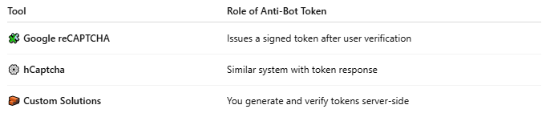

Tool | Role of Anti-Bot Token
🧩 Google reCAPTCHA | Issues a signed token after user verification
⚙️ hCaptcha | Similar system with token response
🧱 Custom Solutions | You generate and verify tokens server-side

📦 Example Token (reCAPTCHA v3):
# Source: AI Source: Provided by: [Data Path: Persons Table -> ID Column: 1, Name_En Column: Motasem Essam] -> From: [Chatgpt (GPT‑5 Mini)] on [1/20/2026]

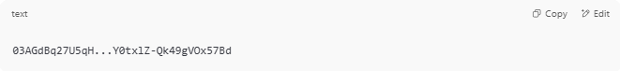
03AGdBq27U5qH...Y0txlZ-Qk49gVOx57Bd

Sent to your server via form or API request.

🧪 Where It’s Used
# Source: AI Source: Provided by: [Data Path: Persons Table -> ID Column: 1, Name_En Column: Motasem Essam] -> From: [Chatgpt (GPT‑5 Mini)] on [1/20/2026]
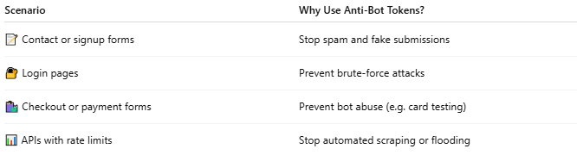

Scenario | Why Use Anti-Bot Tokens?
📝 Contact or signup forms | Stop spam and fake submissions
🔐 Login pages | Prevent brute-force attacks
🛍️ Checkout or payment forms | Prevent bot abuse (e.g. card testing)
📊 APIs with rate limits | Stop automated scraping or flooding

✅ Anti-Bot Token vs CSRF Token
# Source: AI Source: Provided by: [Data Path: Persons Table -> ID Column: 1, Name_En Column: Motasem Essam] -> From: [Chatgpt (GPT‑5 Mini)] on [1/20/2026]
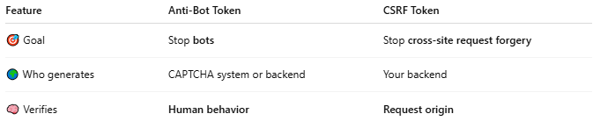

Feature | Anti-Bot Token | CSRF Token
🎯 Goal | Stop bots | Stop cross-site request forgery
🌍 Who generates | CAPTCHA system or backend | Your backend
🧠 Verifies | Human behavior | Request origin

⚠️ Security Best Practices
# Source: AI Source: Provided by: [Data Path: Persons Table -> ID Column: 1, Name_En Column: Motasem Essam] -> From: [Chatgpt (GPT‑5 Mini)] on [1/20/2026]
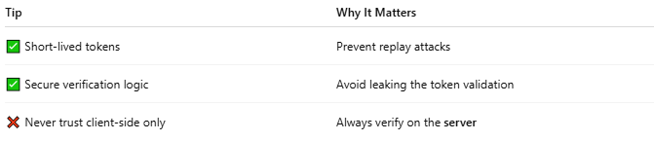

Tip | Why It Matters
✅ Short-lived tokens | Prevent replay attacks
✅ Secure verification logic | Avoid leaking the token validation
❌ Never trust client-side only | Always verify on the server

📌 Summary
# Source: AI Source: Provided by: [Data Path: Persons Table -> ID Column: 1, Name_En Column: Motasem Essam] -> From: [Chatgpt (GPT‑5 Mini)] on [1/20/2026]
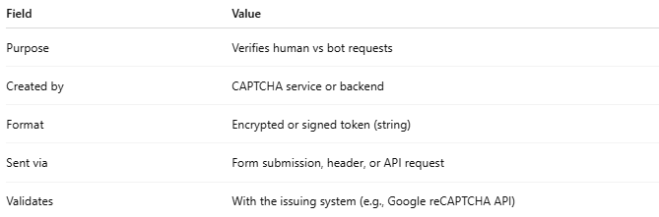

Field | Value
Purpose | Verifies human vs bot requests
Created by | CAPTCHA service or backend
Format | Encrypted or signed token (string)
Sent via | Form submission, header, or API request
Validates | With the issuing system (e.g., Google reCAPTCHA API)

